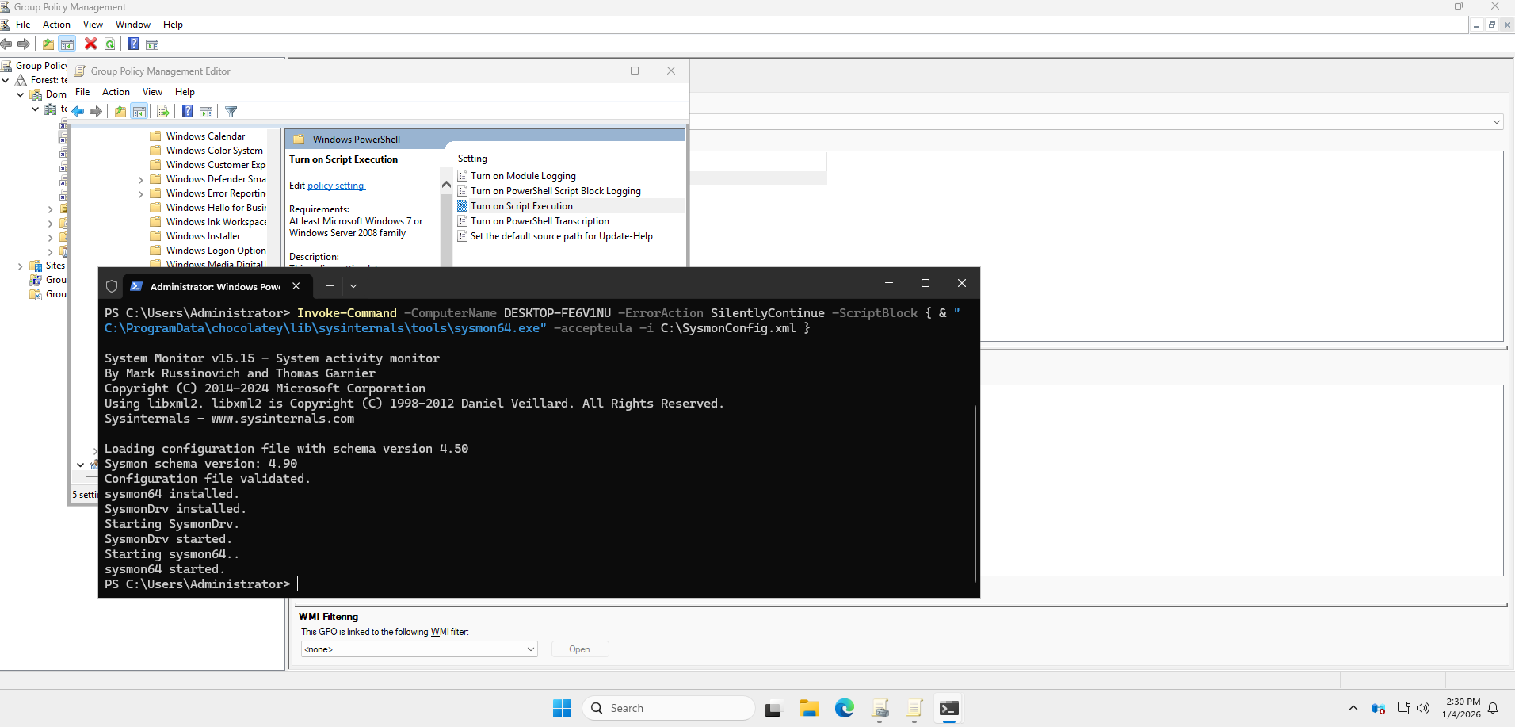
Sysmon and Enhanced Logging
A pre-configured Sysmon configuration file was downloaded to the workstation remotely from the Domain Controller.
PowerShell command used:
Invoke-Command -ComputerName DESKTOP-FE6V1NU -ScriptBlock {
Invoke-WebRequest -Uri "https://raw.githubusercontent.com/SwiftOnSecurity/sysmon-config/master/sysmonconfig-export.xml" -OutFile "C:\SysmonConfig.xml" }
Sysmon Installation and Configuration
Sysmon was installed on the workstation using the downloaded configuration file.
PowerShell command used:
Invoke-Command -ComputerName DESKTOP-FE6V1NU -ErrorAction SilentlyContinue -ScriptBlock {
& "C:\ProgramData\chocolatey\lib\sysinternals\tools\sysmon64.exe" -accepteula -i C:\SysmonConfig.xml}
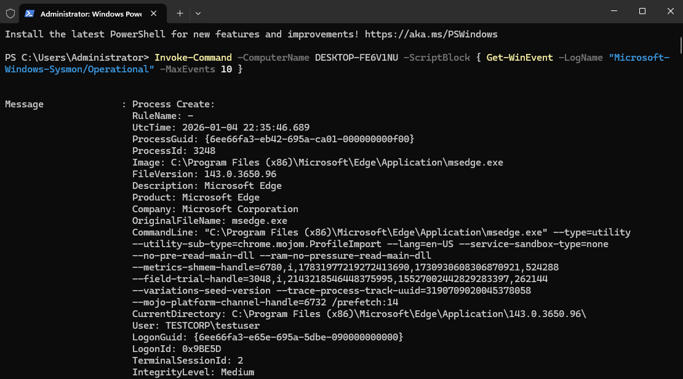
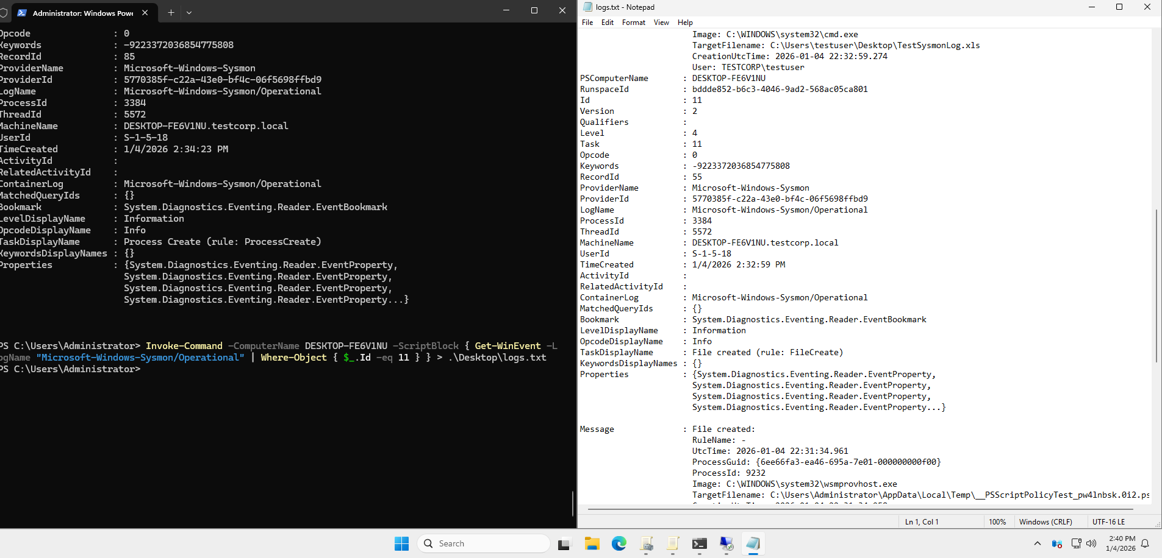
Log Inspection and Export
From the Domain Controller, Sysmon logs were inspected and exported to a file for easier review and analysis, confirming that enhanced logging was successfully enabled.

